A report on

Criminal records with hearing schedules,

status and judges allotted with judgement

Submitted by

**Adepu Nithinvas(20bcs017)**

**Rayapur Pradham(20bcs181)**

**Vadhyavath Naveen (20bec117)**

**CSE, 2nd year**

Submitted to

**Prof. Pritee Khanna**



PDPM INDIAN INSTITUTE OF INFORMATION TECHNOLOGY, DESIGN AND

MANUFACTURING JABALPUR, INDIA

November 16th , 2021

Criminal records

1. Introduction
2. Purpose & Scope
3. Users
4. Overall Description
   1. System Features and Requirements
   2. Functional Requirements
   3. External Interface Requirements
   4. Non-functional Requirements
5. Technology Used
6. Database Designing
   1. Entity Relationship Diagram (ERD)
7. Project Screenshots

Criminal records

1. **INTRODUCTION**

This document lays out a project plan for the development of the “CRIMINAL RECORDS”. The intended readers of this document are respectable professor and teaching assistants. This document focuses on explaining the aspects and functionality of the project.

1. **PURPOSE AND SCOPE**

In today’s world, owning to the heavy workload on the police officers and court judges , they are having a huge amount of stress in their lives. With the presence of so much of paperwork in and around them, they are not able to decrease their workload. we aim to develop an application that would enable them to reduce paperwork and increase the efficiency in managing the data.

The scope is to enable a user-friendly platform to store and retrieve the criminal records with least efforts.

1. **USERS**
2. Admin
3. Judge
4. Police
5. **OVERALL DESCRIPTION**
6. **SYSTEM FEATURES AND REQUIREMENTS**

**The requirements of this project are:**

* A web based front end for Judge registration by entering Judge details including the id, name, password, case number, hearing status, email and hearing date.
* A web based front end for searching, adding, deleting the criminal and traffic records by admin and police with criminal id
* A web based front end for logging in and seeing his allotted case, status and hearing date.
* A web based front end for police registration by entering police details including the id, name, password, address, phone number, email.
* A relational database schema to store, retrieve and update the data in an efficient way.

1. **FUNCTIONAL REQUIREMENTS**

Three modules are used in this project namely Admin, Police and Judge

* Admin can add police and judge.
* Admin can insert, delete criminal records and judges hearing schedule and status.
* Police can login using credentials provided by Admin.
* Police can search, add and insert criminal and traffic records.
* Judge can login using credentials provided by Admin.
* Judge can see the case allotted , status and hearing time of the allotted case

1. **NON-FUNCTIONAL REQUIREMENTS**

* **Hardware specification**

Processor : i5 Core Processor

Clock speed : 2.5 GHz

Monitor : 1078*768 Resolution color

Keyboard : QWERTY

RAM : 4 GB

* Software specification

MySQL Libraries

MySQL server

Operating system : Windows 10

1. **TECHNOLOGY USED**
2. HTML
3. CSS
4. PHP
5. MYSQL
6. **DATABASE DESIGNING**
7. **ENTITY RELATIONSHIP DIAGRAM**

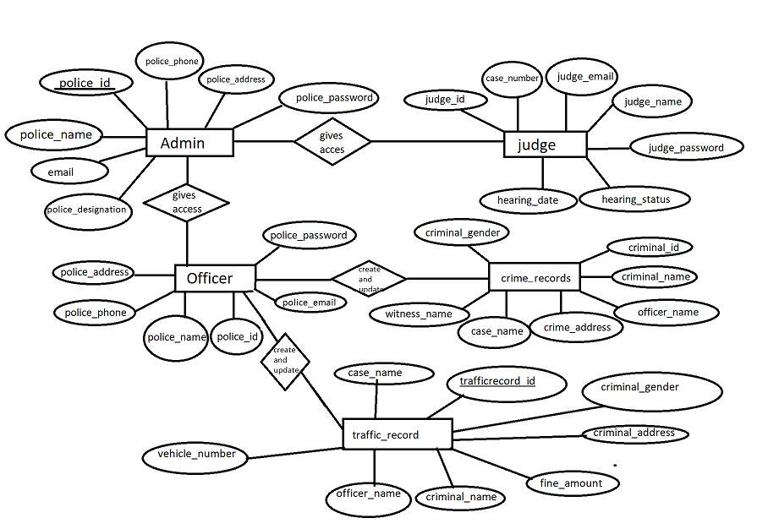

1. **PROJECT SCREENSHOTS**



